“How to Start a SaaS Company in 2025: A Step-by-Step Guide for Founders
July 28, 2025
By
Irina Maltseva
Saying the SaaS industry is lucrative is a bit like describing Jeff Bezos as ‘well off’ — a vast understatement. Estimated to hit an eye-watering market volume of $334 billion by 2027, it continues to experience unprecedented growth, primarily due to the dual effects of a global uptake in both cloud computing and remote working.
If you’re pondering the profit-driving potential of starting your own SaaS company, particularly if you’re targeting the US market, be prepared for some stiff competition. It’s a sector dominated by some of the biggest (and most business-savvy) brands on the planet. We’re talking Microsoft, Adobe, OpenAI, and thousands of nimble startups all vying for a slice of the pie.
But don’t let that deter you!look
With the right approach, and a refusal to wilt in the face of adversity, small players can (and often do) carve out profitable niches. Canva is a prime example of this — their founder, Melanie Perkins, suffered over 100 rejections before her vision of an accessible, collaborative design platform struck gold.
So, whether you’re a technical founder with extensive coding experience or a business-minded entrepreneur with a vision of the next big SaaS hit, our roadmap will help you travel the long road from concept to profit. From validating your idea and securing funding, through to building your product and attracting your first customers, we’ll cover everything you need to know.
Find your niche
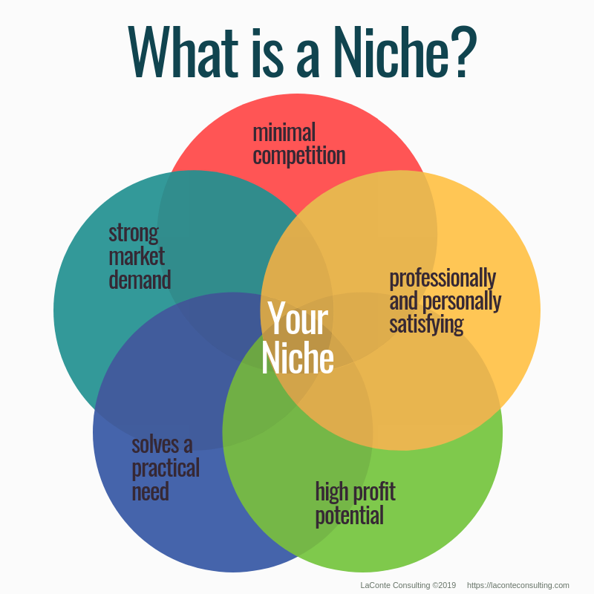
Source: Laconteconsulting
‍
In 2025’s SaaS landscape, specificity matters. The days of “We’re building Uber for X” or “It’s like Airbnb but for Y” are long gone. If you’re shooting for success, you’ve got to address a very specific pain point for a very specific audience.
If your best idea boils down to a reskinned version of something that’s already dominating the market, it’s probably time to go back to the drawing board. Siphoning inspiration from the industry giants is fine, of course, but you’ve got to offer something different.
Take Pipedrive, for example. They didn't try to compete head-on with Salesforce by building yet another generic CRM. Instead, they laser-focused on small sales teams that found existing CRMs overwhelming. This hyper-specificity allowed them to grow from zero to 100,000+ customers across 179 countries.
Your mission: Identify a narrow audience segment experiencing a problem that's:
- Expensive (either in money, time, or emotional cost)
- Frequent (they encounter it regularly)
- Urgent (can't be put off indefinitely)
- Underserved by current solutions
This level of focus might feel counterintuitive — surely casting a wider net catches more fish? Not in SaaS. The riches are in the niches.
Validate your business
You’ve got your brilliant idea — what next? This is just the starting point. The SaaS graveyard is littered with concepts that, on the surface, were great — but nobody fancied paying for them.
So, before writing a single line of code or pitching to investors, apply these validation techniques:
The problem interview
Conduct at least 20 interviews with potential customers. Don't pitch your solution — instead, probe deeply into their problems. Questions like:
- "What's the hardest part about X?"
- "How are you solving this today?"
- "What would your ideal solution look like?"
- "How much time/money does this problem cost you monthly?"
The smoke test
Create a landing page describing your solution and include a “Pre-register” or “Join Waitlist” button. Run targeted ads to drive traffic. A conversion rate above 5% suggests strong interest.
The pre-sale challenge
The ultimate validation: can you sell it before building it?
Stripe Atlas founder Patrick McKenzie advocates this approach: “If you can get 10 people to hand you money for a product that doesn't exist yet, you've validated demand better than 99% of startups.”
Patio11 (as he's known online) isn't exaggerating. When Basecamp (formerly 37signals) launched their first product, they pre-sold access to cover development costs. Customers who pay before seeing your product are sending the strongest possible signal that your solution addresses a genuine need.
Develop an MVP
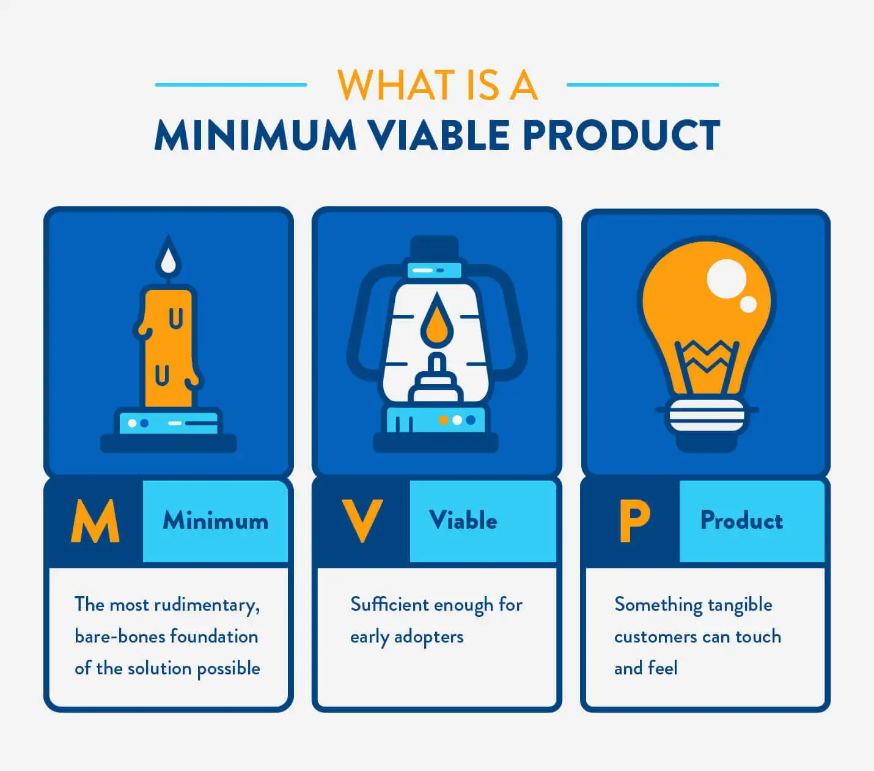
Source: CleverTap
Always remember, perfection is the enemy of progress. Your MVP (That’s Minimal Viable Product) should focus on solving one core problem exceptionally well, rather than addressing multiple pain points adequately.
Take Remote (a popular alternative to Rippling), for example: during the first few years of its launch, it focused on delivering a stable, reliable Employer of Record service offering. It wasn’t until 2023 that Remote launched its Global HR Platform, which included talent management and time and attendance tracking tools.
The modern MVP tech stack
For non-technical founders, no-code and low-code platforms have matured significantly by 2025:
- Webflow + Memberstack: For membership sites and simple SaaS apps
- Bubble: For more complex applications with custom workflows
- n8n/Make: For integration-heavy SaaS products
For technical founders, the serverless architecture approach offers speed and scalability:
- Frontend: React/Next.js or Vue.js/Nuxt
- Backend: Serverless functions via AWS Lambda, Vercel, or Firebase
- Database: MongoDB Atlas, Supabase, or PlanetScale
- Authentication: Auth0, Clerk, or Supabase Auth
- API Management: API Gateway or Hasura
Remember: Your tech stack should optimize for speed of iteration, not theoretical scale. Instagram reached 100 million users on AWS before needing custom infrastructure. You’ll have luxury problems if you reach that scale.
Set the right price
If there’s one consistent mistake first-time SaaS founders make, it's underpricing their product. In 2025’s inflationary environment, this error is particularly costly.
So, if you’re thinking about undercutting your competition, think again, because:
- Enterprise customers associate higher prices with higher quality
- Lower prices attract price-sensitive customers who churn more often
- Higher prices give you margin to invest in customer acquisition
- You can always lower prices later (raising them is much harder)
Consider the following pricing structures:
The 10x rule
Your solution should deliver at least 10x the value of what you charge. If your SaaS saves a business $10,000 in annual costs or generates $10,000 in additional revenue, a $1,000/year price point is justifiable.
Tiered pricing
Most successful SaaS companies offer 3-4 different pricing tiers. For example:
- A lower-priced tier to capture SMBs and provide social proof
- A middle tier priced to maximize revenue (this should be your “suggested” plan)
- A premium tier with enterprise features that makes the middle tier look reasonable
Annual billing incentives
Offer a meaningful discount (typically 20-25%) for annual commitments. This improves cash flow and reduces churn risk.
Usage-based pricing
Hybrid pricing models that combine subscription fees with usage-based components offer the best of both worlds: predictable base revenue plus upside from power users.
Build your growth engine
Now, it’s time to get people using your service. Because no matter how elegant your code or brilliant your UI, if you can’t get eyeballs on the product, you’re not running a SaaS company — you’re running a really expensive hobby.
Acquisition is just one side of the coin. Retention is the flip side, and together they form your growth engine. Here's how to kick it into gear:
Nail your positioning
You’re not just selling a product — you’re selling a story. Your positioning defines who your product is for, why it exists, and how it’s different from alternatives. Think of it as your SaaS company’s internal compass. If you can’t explain your product to a stranger in 10 seconds, you’re not ready to scale.
‍
Use the framework:
[Product] helps [Target User] achieve [Value Proposition] by [Unique Mechanism]
‍
Example:
“Notion helps remote teams stay organised by combining docs, tasks, and wikis into one collaborative workspace.”
Pick your channels wisely
SaaS isn’t a one-size-fits-all marketing game. Instead of going full blast on every possible channel, double down on the 1-2 that make sense for your niche.
- SEO + content: Great for founders targeting a long-term, compounding growth strategy.
- Cold outreach: Still highly effective in B2B. Just make sure you personalize. A “Hey {{FirstName}}!” isn’t personalization — it’s spam with lipstick.
- Communities: Forums like Substack, Reddit, and niche Discord groups can help you build early champions.
- Partnerships: Integrate with bigger platforms or adjacent tools. If your product adds value to someone else’s ecosystem, align incentives and go to market together.
Track obsessively
You can’t improve what you don’t measure. Here are your early-stage SaaS KPIs:
- Activation rate: Are users hitting your “aha!” moment? Define what that moment is, and track how many get there.
- Churn rate: Keep an eye on retention like your life depends on it — because it does.
- Customer Acquisition Cost (CAC): How much are you paying to land a customer?
- Customer Lifetime Value (LTV): How much will they pay you before they bounce? LTV should ideally be 3x your CAC. If it’s not — either fix your product, your pricing, or your targeting.
Scale up
Once you’re growing steadily and have product-market fit (you’ll know — because everything gets a little easier), it’s time to operationalize. This isn’t the sexy part, but it’s what separates hobby projects from serious businesses.
Don’t treat support like a cost center. Every interaction is a chance to turn a lukewarm user into a raving fan. Use tools like Intercom, Help Scout, or Zendesk, and consider offering live chat or Slack communities for high-value clients.
Once you have consistent workflows, graduate to full SOPs and team ownership. You want to free yourself from the weeds so you can work on the business, not in it, so automate the repetitive stuff!
Hire slow, fire fast
You don’t need a big team to scale — you need the right one. That means:
- Smart generalists early on
- Domain experts later, as you scale functions
- Cultural fit over raw credentials
And don’t be afraid to use freelancers or fractional execs to plug gaps in the meantime. Plus, it's worth providing your employees with the security software like MacKeeper to help keep their macOS devices clean and optimized for better work as well as avoid viruses and ads. Equally important is building a positive work culture through employee rewards and recognition, which can boost morale and encourage long-term commitment from your team.
Find funding
Bootstrapping is badass. But sometimes, scale demands speed — and that’s where outside capital comes in.
Funding options include:
- Bootstrapping: Ideal if you’re profitable early, want to maintain control, or are building for lifestyle + freedom.
- Angel investors: Great for early capital plus connections. Look for operator-angels who’ve built SaaS before. To attract these investors, it could be beneficial to turn to pitch deck professionals and ask them to create an eye-catching pitch for you.
- Revenue-based financing: Non-dilutive capital options like Pipe, Capchase, or Founderpath are great if you have predictable MRR.
- VCs: If you’re swinging for the unicorn fences, venture funding gives you rocket fuel — but be prepared to give up equity, control, and potentially, optionality.
SaaS success comes down to your obsession with solving a painful, persistent problem for people who are willing to pay you for the privilege. If you stay close to your customers, move fast without breaking trust, and build with ruthless clarity, you’ll give yourself every chance to thrive. So go forth. Ship the MVP. Charge real money. Talk to users. And build something people actually want. Good luck!”

